NEBKC-PICID/EN19
 | INFORMATIONS DOG |  | INFORMATIONS OWNER
 | Name : |  | Affix: //
 | Breed : |  | Name :
 | DOB : |  | Street/Nr.
 | Gender : |  | NPA, Location :
 | Chip : |  | Email :
 | DNA : |  | Tel : +
 | Pedigree Nr : |  | Breeder license nr.
 | Other : |  | Website :
VETERINARIAN IDENTIFICATION FORM FOR ONLINE CONFIRMATION
Confirmation age from 12 months
Insert the requested pictures in the 4 cases after removing sample drawings, pictures need to be inserted by Word, not glued on the form, and data above must be typed, not handwitten. Once complete, please print out . To be signed and stamped by your veterinarian.
RIGHT PROFILE, ENTIRE DOG |  | LEFT PROFILE, ENTIRE DOG
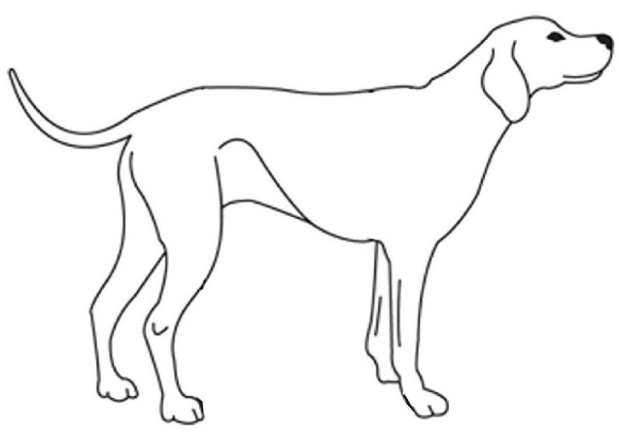 |  | 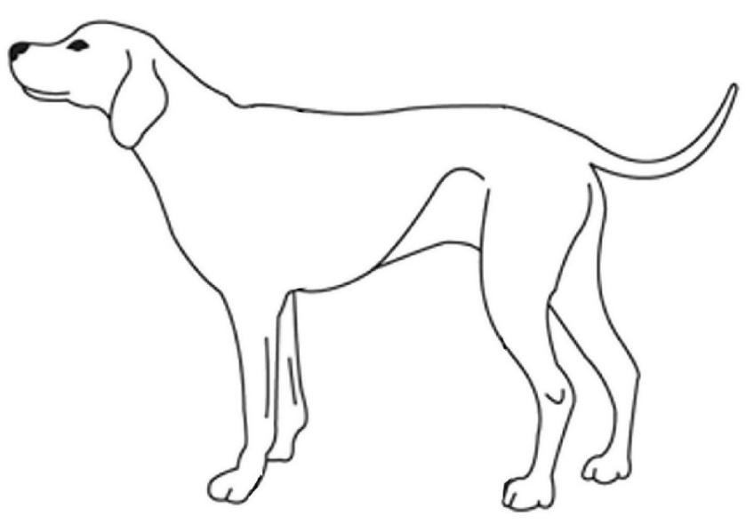
FRONT, ENTIRE DOG |  | REAR, ENTIRE DOG
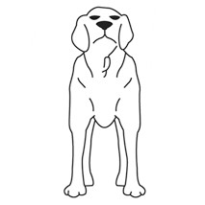 |  | 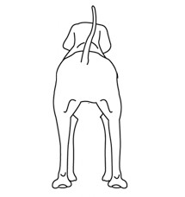
The undersigned veterinarian certifies that the dog in the photos is indeed the one whose data appears at the top of the page under "dog information" and that he has been identified by its chip nr.  This form (Nr. 5), along with the form Nr. 6 wich was also completed by the veterinarian, must be sent to info@nebkc.com by the dog’s owner, together with the 4 short videos and the dog’s pedigree. |  | Signature, Name & Stamp of the veterinarian:  NAME : Dr.  LOCATION : DATE :
The veterinarian is asked to archive this examination in the dog’s file in case of a control by us.
© NEBKC, Npo, Po Box 2746, 1211 Geneva 2, Switzerland, Tel. : +41 22 535 29 14, info@nebkc.com, www.nebkc.com

